**Lesson 08 Demo 2**

**Pod Creation in Kubernetes**



Steps to be followed:

1. Creating multi-container pods
2. Creating a single container pod

**Step 1: Creating multi-container pods**

1. On the *master* node, create a new file named *sample.yaml:*

***sudo su***

***vi sample.yaml***

1. Add the following code in the *sample.yaml* file:

***apiVersion: v1***

***kind: Pod***

***metadata:***

***name: multi-container***

***spec:***

***terminationGracePeriodSeconds: 0***

***containers:***

***- name: nginx***

***image: nginx:1.10-alpine***

***ports:***

***- containerPort: 80***

***- name: alpine***

***image: alpine:3.5***

***command: ["watch", "wget", "-qO-", "localhost"]***

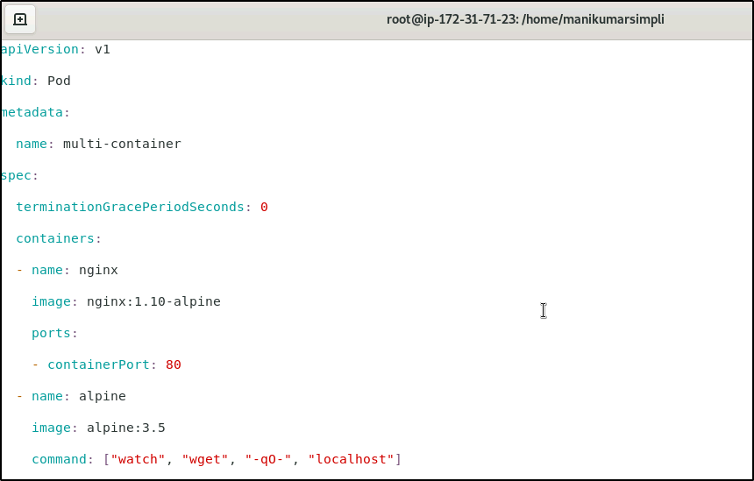

1. Use the following command to create the *multi-container*pod:

***kubectl create -f sample.yaml***

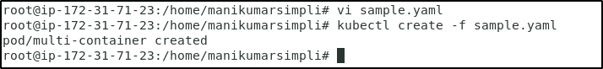

**Step 2: Creating a single container pod**

1. On the *master*node, create a single container pod with a tomcat image using the following command:

***kubectl run tomcat --image=tomcat:8.0***



1. Check all the running pods

***kubectl get pods***

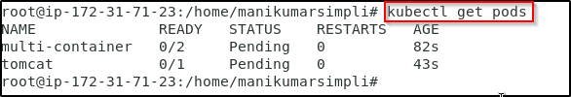

1. To check why exactly a pod is in the pending state, run the command

***kubectl describe pods <pod_name>***

To check why multi-container pod is pending,use the command

***kubectl describe pods multi-container***

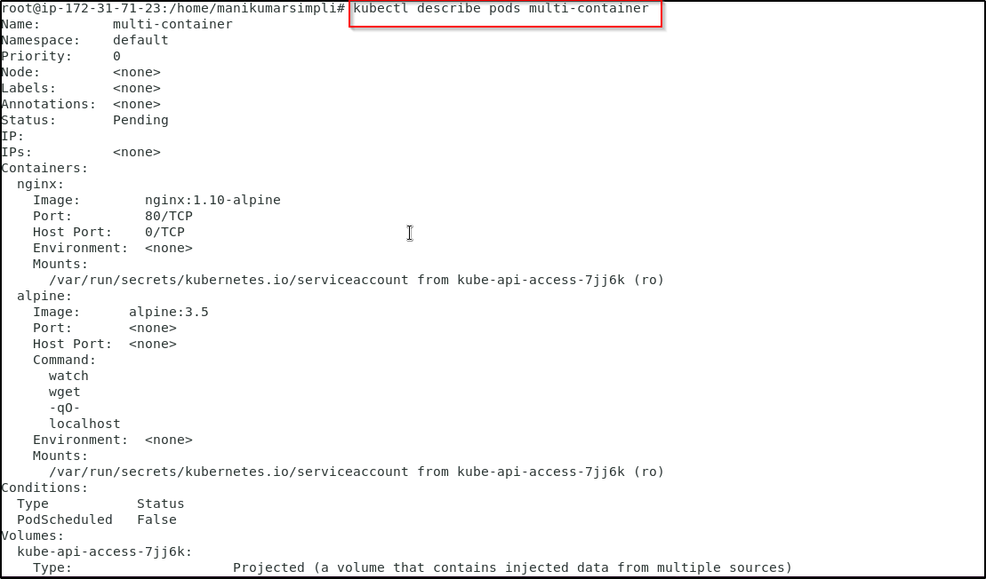

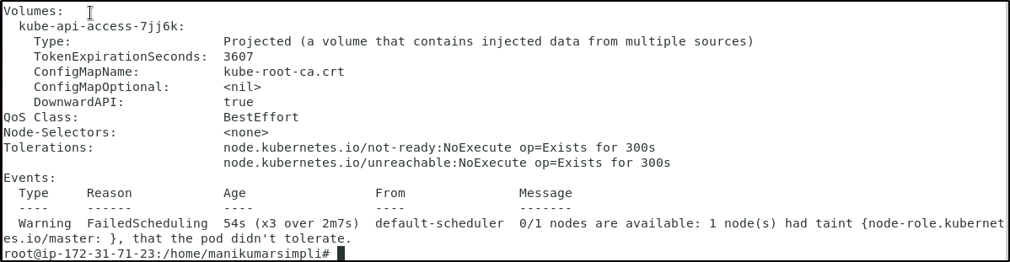

1. To remove the taint from the node run the following commands:

***kubectl get nodes***

Copy the node name and use it in the below command

***kubectl taint nodes <node name> node-role.kubernetes.io/master-***

Here for example we use the command given below

***kubectl taint nodes ip-172-31-18-183 node-role.kubernetes.io/master-***

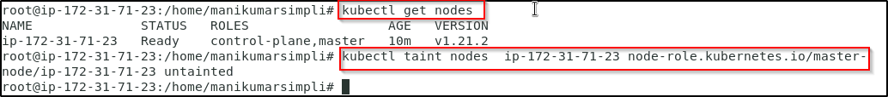

1. Now check the pod status. The pods should be in the running state.

***sudo kubectl get pods***

